**Problem Statement:**

You work for XYZ Corporation. To maintain the security of the AWS account and

the resources you have been asked to implement a solution that can help easily

recognize and monitor the different users.

**Tasks To Be Performed:**

1. Create a role which only lets user1 and user2 from task 1 to have complete

access to VPCs and DynamoDB.

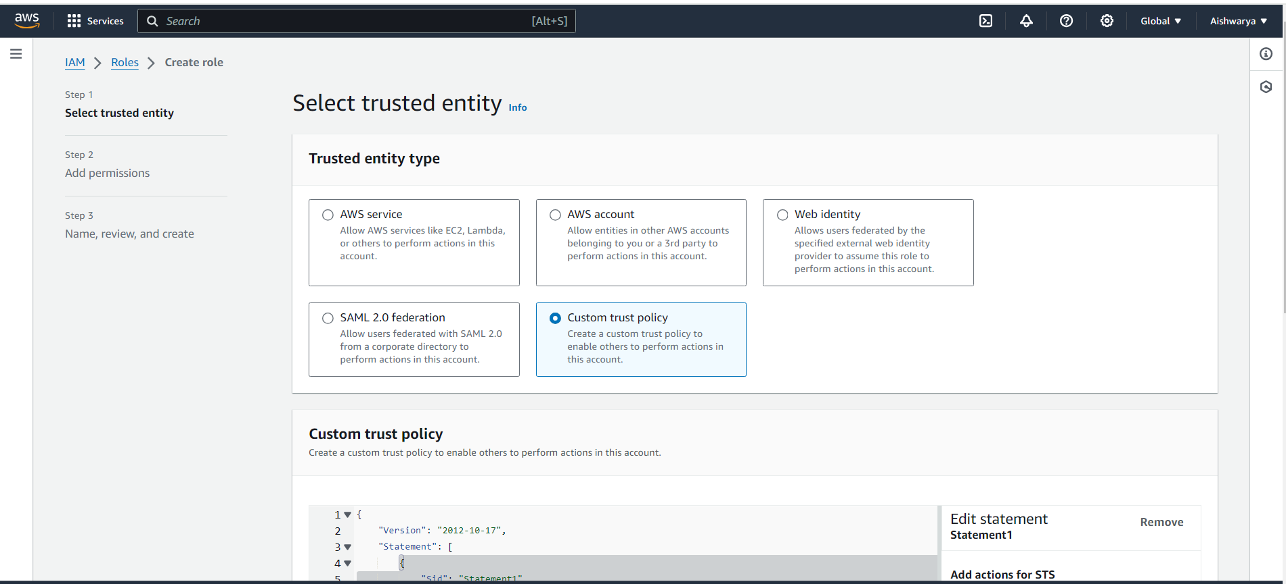

Add ARN of 2 users

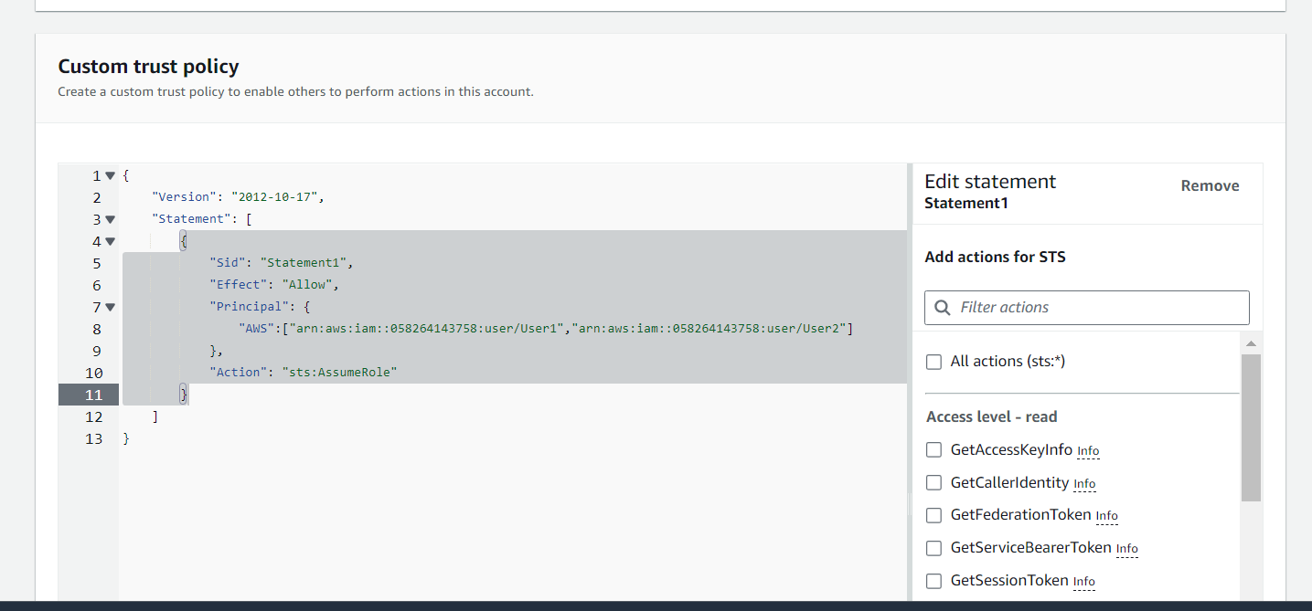

Give permission for DynamoDB and VPC full access

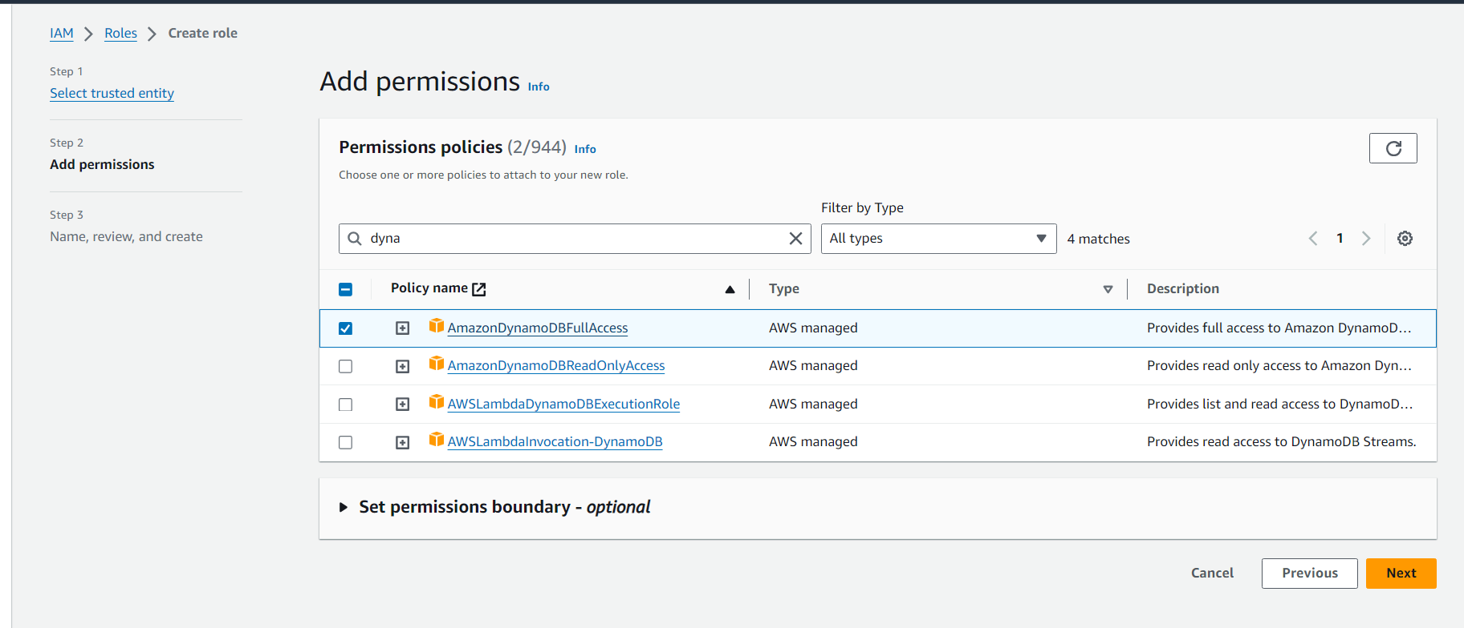

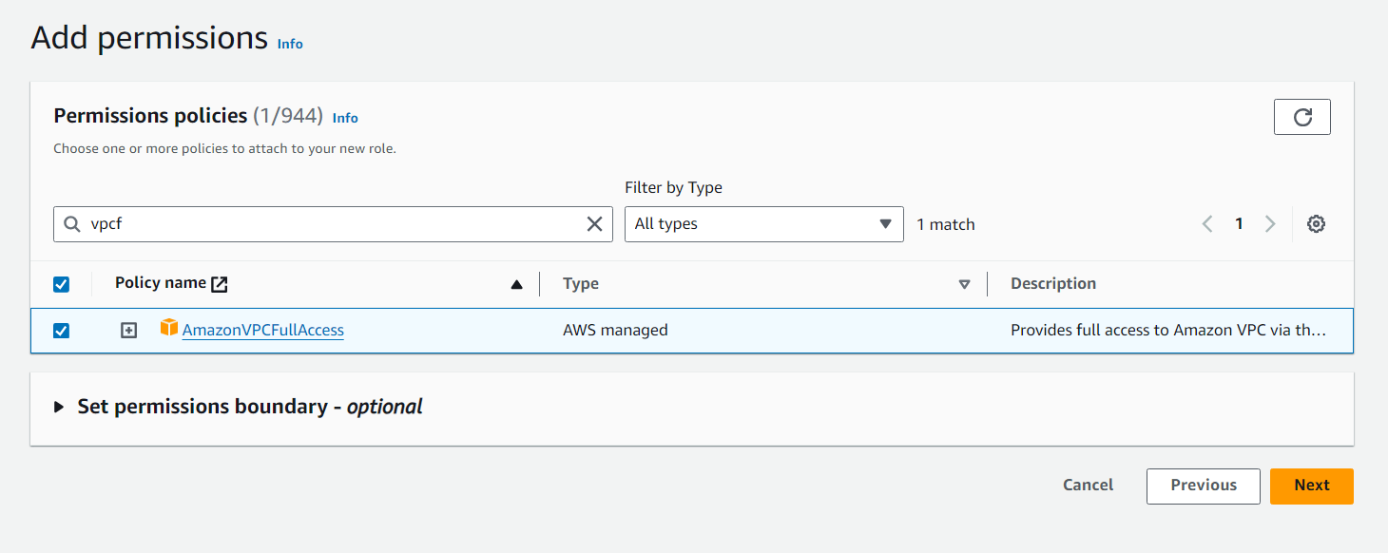

Review all and create role.

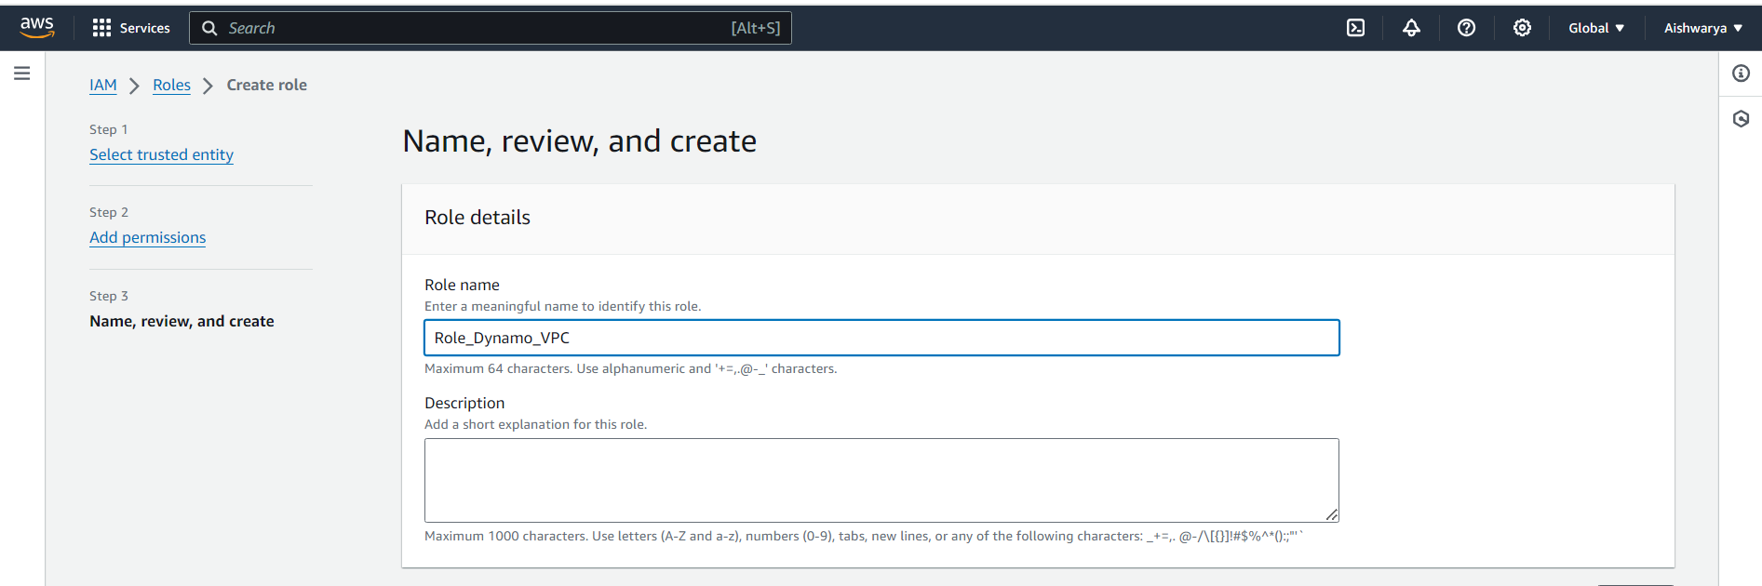

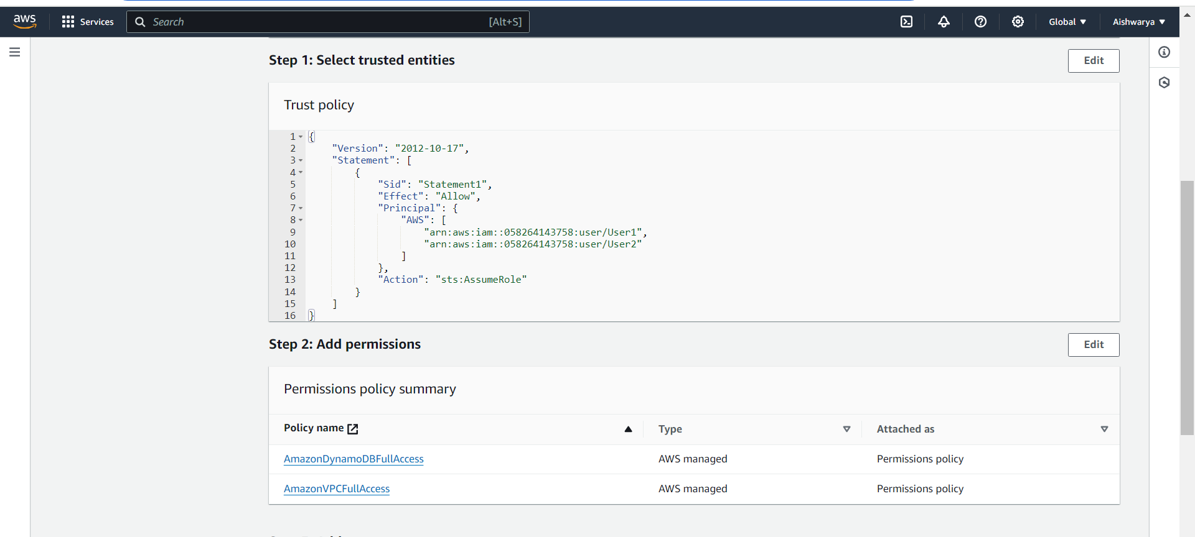

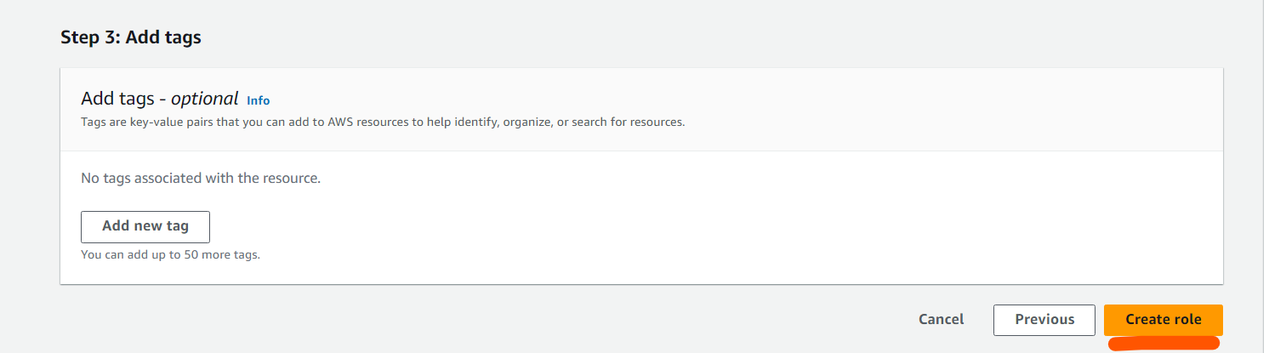

2. Login into user1 and shift to the role to test out the feature.

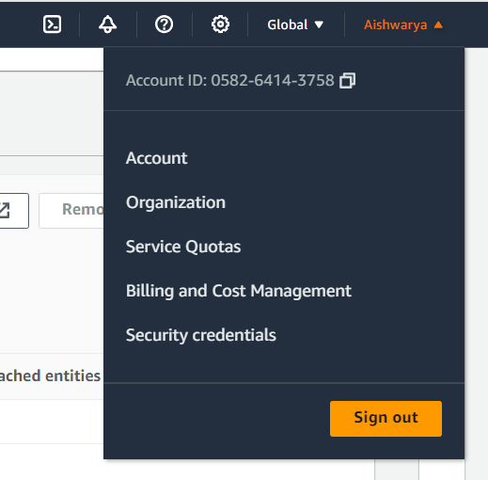

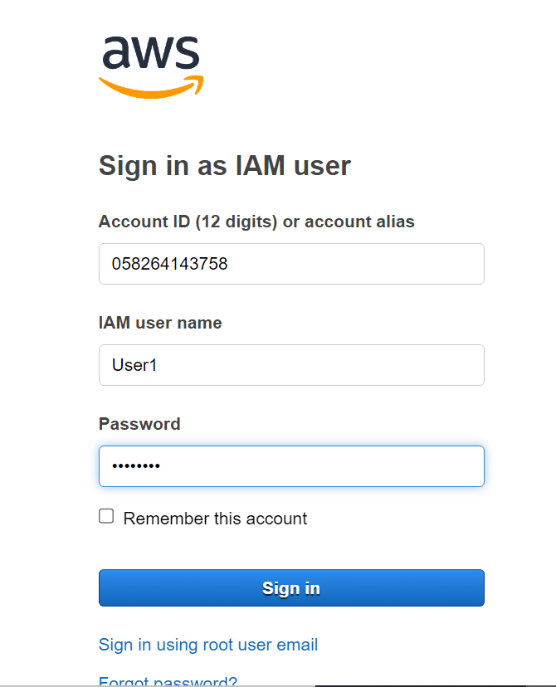

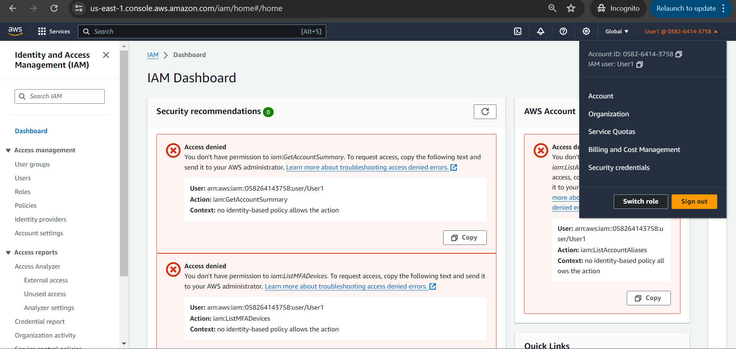

Switch to Role

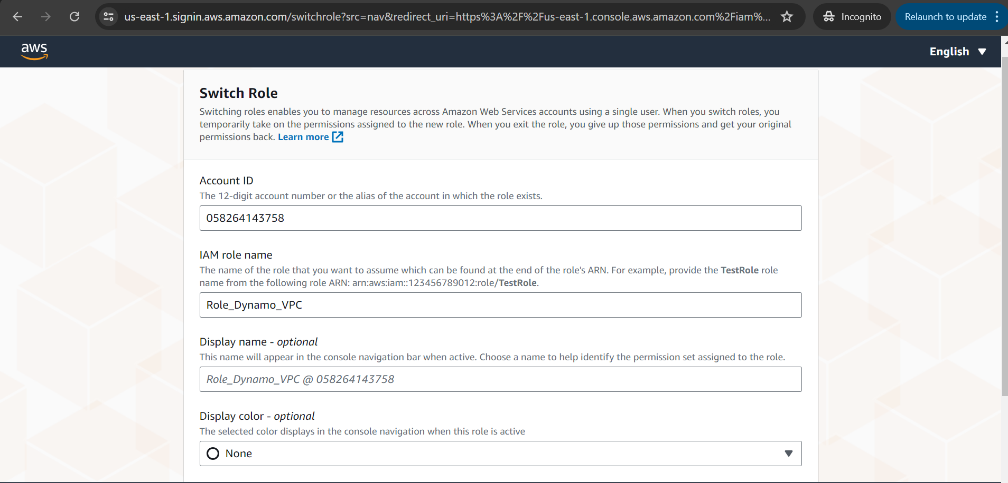

Able to access VPC and DynamoDB

